Khang Dao

Mark Garcia

Brenda Solis

Build Lab Database

1. List all rows from Customer
   1. select * from CUSTOMERS;

|  |  |  |  |  |  |  |  |  |  |  |  |  |
| --- | --- | --- | --- | --- | --- | --- | --- | --- | --- | --- | --- | --- |
| CUSTOMERNUMBER | CUSTOMERNAME | CONTACTLASTNAME | CONTACTFIRSTNAME | PHONE | ADDRESSLINE1 | ADDRESSLINE2 | CITY | STATE | POSTALCODE | COUNTRY | SALESREPEMPLOYEENUMBER | CREDITLIMIT |
| 103 | Atelier graphique | Schmitt | Carine | 40.32.2555 | 54, rue Royale | "" | Nantes | "" | 44000 | France | 1370 | 21000.00 |
| 112 | Signal Gift Stores | King | Jean | 7025551838 | 8489 Strong St. | "" | Las Vegas | NV | 83030 | USA | 1166 | 71800.00 |
| 114 | Australian Collectors, Co. | Ferguson | Peter | 03 9520 4555 | 636 St Kilda Road | Level 3 | Melbourne | Victoria | 3004 | Australia | 1611 | 117300.00 |
| 119 | La Rochelle Gifts | Labrune | Janine | 40.67.8555 | 67, rue des Cinquante Otages | "" | Nantes | "" | 44000 | France | 1370 | 118200.00 |
| 121 | Baane Mini Imports | Bergulfsen | Jonas | 07-98 9555 | Erling Skakkes gate 78 | "" | Stavern | "" | 4110 | Norway | 1504 | 81700.00 |
| 124 | Mini Gifts Distributors Ltd. | Nelson | Susan | 4155551450 | 5677 Strong St. | "" | San Rafael | CA | 97562 | USA | 1165 | 210500.00 |
| 125 | Havel & Zbyszek Co | Piestrzeniewicz | Zbyszek | (26) 642-7555 | ul. Filtrowa 68 | "" | Warszawa | "" | 01-012 | Poland | "" | 0.00 |
| 128 | Blauer See Auto, Co. | Keitel | Roland | +49 69 66 90 2555 | Lyonerstr. 34 | "" | Frankfurt | "" | 60528 | Germany | 1504 | 59700.00 |
| 129 | Mini Wheels Co. | Murphy | Julie | 6505555787 | 5557 North Pendale Street | "" | San Francisco | CA | 94217 | USA | 1165 | 64600.00 |
| 131 | Land of Toys Inc. | Lee | Kwai | 2125557818 | 897 Long Airport Avenue | "" | NYC | NY | 10022 | USA | 1323 | 114900.00 |
| 141 | Euro+ Shopping Channel | Freyre | Diego | (91) 555 94 44 | C/ Moralzarzal, 86 | "" | Madrid | "" | 28034 | Spain | 1370 | 227600.00 |
| 144 | Volvo Model Replicas, Co | Berglund | Christina | 0921-12 3555 | BerguvsvÃ¤gen 8 | "" | LuleÃ¥ | "" | S-958 22 | Sweden | 1504 | 53100.00 |
| 145 | Danish Wholesale Imports | Petersen | Jytte | 31 12 3555 | VinbÃ¦ltet 34 | "" | Kobenhavn | "" | 1734 | Denmark | 1401 | 83400.00 |
| 146 | Saveley & Henriot, Co. | Saveley | Mary | 78.32.5555 | 2, rue du Commerce | "" | Lyon | "" | 69004 | France | 1337 | 123900.00 |
| 148 | Dragon Souveniers, Ltd. | Natividad | Eric | +65 221 7555 | Bronz Sok. | Bronz Apt. 3/6 Tesvikiye | Singapore | "" | 079903 | Singapore | 1621 | 103800.00 |
| 151 | Muscle Machine Inc | Young | Jeff | 2125557413 | 4092 Furth Circle | Suite 400 | NYC | NY | 10022 | USA | 1286 | 138500.00 |
| 157 | Diecast Classics Inc. | Leong | Kelvin | 2155551555 | 7586 Pompton St. | "" | Allentown | PA | 70267 | USA | 1216 | 100600.00 |
| 161 | Technics Stores Inc. | Hashimoto | Juri | 6505556809 | 9408 Furth Circle | "" | Burlingame | CA | 94217 | USA | 1165 | 84600.00 |
| 166 | Handji Gifts& Co | Victorino | Wendy | +65 224 1555 | 106 Linden Road Sandown | 2nd Floor | Singapore | "" | 069045 | Singapore | 1612 | 97900.00 |
| 167 | Herkku Gifts | Oeztan | Veysel | +47 2267 3215 | Brehmen St. 121 | PR 334 Sentrum | Bergen | "" | N 5804 | Norway | 1504 | 96800.00 |
| 168 | American Souvenirs Inc | Franco | Keith | 2035557845 | 149 Spinnaker Dr. | Suite 101 | New Haven | CT | 97823 | USA | 1286 | 0.00 |
| 169 | Porto Imports Co. | de Castro | Isabel | (1) 356-5555 | Estrada da saÃºde n. 58 | "" | Lisboa | "" | 1756 | Portugal | "" | 0.00 |
| 171 | Daedalus Designs Imports | RancÃ© | Martine | 20.16.1555 | 184, chaussÃ©e de Tournai | "" | Lille | "" | 59000 | France | 1370 | 82900.00 |
| 172 | La Corne D'abondance, Co. | Bertrand | Marie | (1) 42.34.2555 | 265, boulevard Charonne | "" | Paris | "" | 75012 | France | 1337 | 84300.00 |
| 173 | Cambridge Collectables Co. | Tseng | Jerry | 6175555555 | 4658 Baden Av. | "" | Cambridge | MA | 51247 | USA | 1188 | 43400.00 |
| 175 | Gift Depot Inc. | King | Julie | 2035552570 | 25593 South Bay Ln. | "" | Bridgewater | CT | 97562 | USA | 1323 | 84300.00 |
| 177 | Osaka Souveniers Co. | Kentary | Mory | +81 06 6342 5555 | 1-6-20 Dojima | "" | Kita-ku | Osaka | 530-0003 | Japan | 1621 | 81200.00 |
| 181 | Vitachrome Inc. | Frick | Michael | 2125551500 | 2678 Kingston Rd. | Suite 101 | NYC | NY | 10022 | USA | 1286 | 76400.00 |
| 186 | Toys of Finland, Co. | Karttunen | Matti | 90-224 8555 | Keskuskatu 45 | "" | Helsinki | "" | 21240 | Finland | 1501 | 96500.00 |
| 187 | AV Stores, Co. | Ashworth | Rachel | (171) 555-1555 | Fauntleroy Circus | "" | Manchester | "" | EC2 5NT | UK | 1501 | 136800.00 |
| 189 | Clover Collections, Co. | Cassidy | Dean | +353 1862 1555 | 25 Maiden Lane | Floor No. 4 | Dublin | "" | 2 | Ireland | 1504 | 69400.00 |
| 198 | Auto-Moto Classics Inc. | Taylor | Leslie | 6175558428 | 16780 Pompton St. | "" | Brickhaven | MA | 58339 | USA | 1216 | 23000.00 |
| 201 | UK Collectables, Ltd. | Devon | Elizabeth | (171) 555-2282 | 12, Berkeley Gardens Blvd | "" | Liverpool | "" | WX1 6LT | UK | 1501 | 92700.00 |
| 202 | Canadian Gift Exchange Network | Tamuri | Yoshi | (604) 555-3392 | 1900 Oak St. | "" | Vancouver | BC | V3F 2K1 | Canada | 1323 | 90300.00 |
| 204 | Online Mini Collectables | Barajas | Miguel | 6175557555 | 7635 Spinnaker Dr. | "" | Brickhaven | MA | 58339 | USA | 1188 | 68700.00 |
| 205 | Toys4GrownUps.com | Young | Julie | 6265557265 | 78934 Hillside Dr. | "" | Pasadena | CA | 90003 | USA | 1166 | 90700.00 |
| 206 | Asian Shopping Network, Co | Walker | Brydey | +612 9411 1555 | Suntec Tower Three | 8 Temasek | Singapore | "" | 038988 | Singapore | "" | 0.00 |
| 209 | Mini Caravy | Citeaux | FrÃ©dÃ©rique | 88.60.1555 | 24, place KlÃ©ber | "" | Strasbourg | "" | 67000 | France | 1370 | 53800.00 |
| 211 | King Kong Collectables, Co. | Gao | Mike | +852 2251 1555 | Bank of China Tower | 1 Garden Road | Central Hong Kong | "" | "" | Hong Kong | 1621 | 58600.00 |
| 216 | Enaco Distributors | Saavedra | Eduardo | (93) 203 4555 | Rambla de CataluÃ±a, 23 | "" | Barcelona | "" | 08022 | Spain | 1702 | 60300.00 |
| 219 | Boards & Toys Co. | Young | Mary | 3105552373 | 4097 Douglas Av. | "" | Glendale | CA | 92561 | USA | 1166 | 11000.00 |
| 223 | NatÃ¼rlich Autos | Kloss | Horst | 0372-555188 | TaucherstraÃŸe 10 | "" | Cunewalde | "" | 01307 | Germany | "" | 0.00 |
| 227 | Heintze Collectables | Ibsen | Palle | 86 21 3555 | Smagsloget 45 | "" | Ã…rhus | "" | 8200 | Denmark | 1401 | 120800.00 |
| 233 | QuÃ©bec Home Shopping Network | FresniÃ¨re | Jean | (514) 555-8054 | 43 rue St. Laurent | "" | MontrÃ©al | QuÃ©bec | H1J 1C3 | Canada | 1286 | 48700.00 |
| 237 | ANG Resellers | Camino | Alejandra | (91) 745 6555 | Gran VÃ­a, 1 | "" | Madrid | "" | 28001 | Spain | "" | 0.00 |
| 239 | Collectable Mini Designs Co. | Thompson | Valarie | 7605558146 | 361 Furth Circle | "" | San Diego | CA | 91217 | USA | 1166 | 105000.00 |
| 240 | giftsbymail.co.uk | Bennett | Helen | (198) 555-8888 | Garden House | Crowther Way 23 | Cowes | Isle of Wight | PO31 7PJ | UK | 1501 | 93900.00 |
| 242 | Alpha Cognac | Roulet | Annette | 61.77.6555 | 1 rue Alsace-Lorraine | "" | Toulouse | "" | 31000 | France | 1370 | 61100.00 |
| 247 | Messner Shopping Network | Messner | Renate | 069-0555984 | Magazinweg 7 | "" | Frankfurt | "" | 60528 | Germany | "" | 0.00 |
| 249 | Amica Models & Co. | Accorti | Paolo | 011-4988555 | Via Monte Bianco 34 | "" | Torino | "" | 10100 | Italy | 1401 | 113000.00 |
| 250 | Lyon Souveniers | Da Silva | Daniel | +33 1 46 62 7555 | 27 rue du Colonel Pierre Avia | "" | Paris | "" | 75508 | France | 1337 | 68100.00 |
| 256 | Auto AssociÃ©s & Cie. | Tonini | Daniel | 30.59.8555 | 67, avenue de l'Europe | "" | Versailles | "" | 78000 | France | 1370 | 77900.00 |
| 259 | Toms SpezialitÃ¤ten, Ltd | Pfalzheim | Henriette | 0221-5554327 | Mehrheimerstr. 369 | "" | KÃ¶ln | "" | 50739 | Germany | 1504 | 120400.00 |
| 260 | Royal Canadian Collectables, Ltd. | Lincoln | Elizabeth | (604) 555-4555 | 23 Tsawassen Blvd. | "" | Tsawassen | BC | T2F 8M4 | Canada | 1323 | 89600.00 |
| 273 | Franken Gifts, Co | Franken | Peter | 089-0877555 | Berliner Platz 43 | "" | MÃ¼nchen | "" | 80805 | Germany | "" | 0.00 |
| 276 | Anna's Decorations, Ltd | O'Hara | Anna | 02 9936 8555 | 201 Miller Street | Level 15 | North Sydney | NSW | 2060 | Australia | 1611 | 107800.00 |
| 278 | Rovelli Gifts | Rovelli | Giovanni | 035-640555 | Via Ludovico il Moro 22 | "" | Bergamo | "" | 24100 | Italy | 1401 | 119600.00 |
| 282 | Souveniers And Things Co. | Huxley | Adrian | +61 2 9495 8555 | Monitor Money Building | 815 Pacific Hwy | Chatswood | NSW | 2067 | Australia | 1611 | 93300.00 |
| 286 | Marta's Replicas Co. | Hernandez | Marta | 6175558555 | 39323 Spinnaker Dr. | "" | Cambridge | MA | 51247 | USA | 1216 | 123700.00 |
| 293 | BG&E Collectables | Harrison | Ed | +41 26 425 50 01 | Rte des Arsenaux 41 | "" | Fribourg | "" | 1700 | Switzerland | "" | 0.00 |
| 298 | Vida Sport, Ltd | Holz | Mihael | 0897-034555 | Grenzacherweg 237 | "" | GenÃ¨ve | "" | 1203 | Switzerland | 1702 | 141300.00 |
| 299 | Norway Gifts By Mail, Co. | Klaeboe | Jan | +47 2212 1555 | Drammensveien 126A | PB 211 Sentrum | Oslo | "" | N 0106 | Norway | 1504 | 95100.00 |
| 303 | Schuyler Imports | Schuyler | Bradley | +31 20 491 9555 | Kingsfordweg 151 | "" | Amsterdam | "" | 1043 GR | Netherlands | "" | 0.00 |
| 307 | Der Hund Imports | Andersen | Mel | 030-0074555 | Obere Str. 57 | "" | Berlin | "" | 12209 | Germany | "" | 0.00 |
| 311 | Oulu Toy Supplies, Inc. | Koskitalo | Pirkko | 981-443655 | Torikatu 38 | "" | Oulu | "" | 90110 | Finland | 1501 | 90500.00 |
| 314 | Petit Auto | Dewey | Catherine | (02) 5554 67 | Rue Joseph-Bens 532 | "" | Bruxelles | "" | B-1180 | Belgium | 1401 | 79900.00 |
| 319 | Mini Classics | Frick | Steve | 9145554562 | 3758 North Pendale Street | "" | White Plains | NY | 24067 | USA | 1323 | 102700.00 |
| 320 | Mini Creations Ltd. | Huang | Wing | 5085559555 | 4575 Hillside Dr. | "" | New Bedford | MA | 50553 | USA | 1188 | 94500.00 |
| 321 | Corporate Gift Ideas Co. | Brown | Julie | 6505551386 | 7734 Strong St. | "" | San Francisco | CA | 94217 | USA | 1165 | 105000.00 |
| 323 | Down Under Souveniers, Inc | Graham | Mike | +64 9 312 5555 | 162-164 Grafton Road | Level 2 | Auckland | "" | "" | New Zealand | 1612 | 88000.00 |
| 324 | Stylish Desk Decors, Co. | Brown | Ann | (171) 555-0297 | 35 King George | "" | London | "" | WX3 6FW | UK | 1501 | 77000.00 |
| 328 | Tekni Collectables Inc. | Brown | William | 2015559350 | 7476 Moss Rd. | "" | Newark | NJ | 94019 | USA | 1323 | 43000.00 |
| 333 | Australian Gift Network, Co | Calaghan | Ben | 61-7-3844-6555 | 31 Duncan St. West End | "" | South Brisbane | Queensland | 4101 | Australia | 1611 | 51600.00 |
| 334 | Suominen Souveniers | Suominen | Kalle | +358 9 8045 555 | Software Engineering Center | SEC Oy | Espoo | "" | FIN-02271 | Finland | 1501 | 98800.00 |
| 335 | Cramer SpezialitÃ¤ten, Ltd | Cramer | Philip | 0555-09555 | Maubelstr. 90 | "" | Brandenburg | "" | 14776 | Germany | "" | 0.00 |
| 339 | Classic Gift Ideas, Inc | Cervantes | Francisca | 2155554695 | 782 First Street | "" | Philadelphia | PA | 71270 | USA | 1188 | 81100.00 |
| 344 | CAF Imports | Fernandez | Jesus | +34 913 728 555 | Merchants House | 27-30 Merchant's Quay | Madrid | "" | 28023 | Spain | 1702 | 59600.00 |
| 347 | Men 'R' US Retailers, Ltd. | Chandler | Brian | 2155554369 | 6047 Douglas Av. | "" | Los Angeles | CA | 91003 | USA | 1166 | 57700.00 |
| 348 | Asian Treasures, Inc. | McKenna | Patricia | 2967 555 | 8 Johnstown Road | "" | Cork | Co. Cork | "" | Ireland | "" | 0.00 |
| 350 | Marseille Mini Autos | Lebihan | Laurence | 91.24.4555 | 12, rue des Bouchers | "" | Marseille | "" | 13008 | France | 1337 | 65000.00 |
| 353 | Reims Collectables | Henriot | Paul | 26.47.1555 | 59 rue de l'Abbaye | "" | Reims | "" | 51100 | France | 1337 | 81100.00 |
| 356 | SAR Distributors, Co | Kuger | Armand | +27 21 550 3555 | 1250 Pretorius Street | "" | Hatfield | Pretoria | 0028 | South Africa | "" | 0.00 |
| 357 | GiftsForHim.com | MacKinlay | Wales | 64-9-3763555 | 199 Great North Road | "" | Auckland | "" | "" | New Zealand | 1612 | 77700.00 |
| 361 | Kommission Auto | Josephs | Karin | 0251-555259 | Luisenstr. 48 | "" | MÃ¼nster | "" | 44087 | Germany | "" | 0.00 |
| 362 | Gifts4AllAges.com | Yoshido | Juri | 6175559555 | 8616 Spinnaker Dr. | "" | Boston | MA | 51003 | USA | 1216 | 41900.00 |
| 363 | Online Diecast Creations Co. | Young | Dorothy | 6035558647 | 2304 Long Airport Avenue | "" | Nashua | NH | 62005 | USA | 1216 | 114200.00 |
| 369 | Lisboa Souveniers, Inc | Rodriguez | Lino | (1) 354-2555 | Jardim das rosas n. 32 | "" | Lisboa | "" | 1675 | Portugal | "" | 0.00 |
| 376 | Precious Collectables | Urs | Braun | 0452-076555 | Hauptstr. 29 | "" | Bern | "" | 3012 | Switzerland | 1702 | 0.00 |
| 379 | Collectables For Less Inc. | Nelson | Allen | 6175558555 | 7825 Douglas Av. | "" | Brickhaven | MA | 58339 | USA | 1188 | 70700.00 |
| 381 | Royale Belge | Cartrain | Pascale | (071) 23 67 2555 | Boulevard Tirou, 255 | "" | Charleroi | "" | B-6000 | Belgium | 1401 | 23500.00 |
| 382 | Salzburg Collectables | Pipps | Georg | 6562-9555 | Geislweg 14 | "" | Salzburg | "" | 5020 | Austria | 1401 | 71700.00 |
| 385 | Cruz & Sons Co. | Cruz | Arnold | +63 2 555 3587 | 15 McCallum Street | NatWest Center #13-03 | Makati City | "" | 1227 MM | Philippines | 1621 | 81500.00 |
| 386 | L'ordine Souveniers | Moroni | Maurizio | 0522-556555 | Strada Provinciale 124 | "" | Reggio Emilia | "" | 42100 | Italy | 1401 | 121400.00 |
| 398 | Tokyo Collectables, Ltd | Shimamura | Akiko | +81 3 3584 0555 | 2-2-8 Roppongi | "" | Minato-ku | Tokyo | 106-0032 | Japan | 1621 | 94400.00 |
| 406 | Auto Canal+ Petit | Perrier | Dominique | (1) 47.55.6555 | 25, rue Lauriston | "" | Paris | "" | 75016 | France | 1337 | 95000.00 |
| 409 | Stuttgart Collectable Exchange | MÃ¼ller | Rita | 0711-555361 | Adenauerallee 900 | "" | Stuttgart | "" | 70563 | Germany | "" | 0.00 |
| 412 | Extreme Desk Decorations, Ltd | McRoy | Sarah | 04 499 9555 | 101 Lambton Quay | Level 11 | Wellington | "" | "" | New Zealand | 1612 | 86800.00 |
| 415 | Bavarian Collectables Imports, Co. | Donnermeyer | Michael | +49 89 61 08 9555 | Hansastr. 15 | "" | Munich | "" | 80686 | Germany | 1504 | 77000.00 |
| 424 | Classic Legends Inc. | Hernandez | Maria | 2125558493 | 5905 Pompton St. | Suite 750 | NYC | NY | 10022 | USA | 1286 | 67500.00 |
| 443 | Feuer Online Stores, Inc | Feuer | Alexander | 0342-555176 | Heerstr. 22 | "" | Leipzig | "" | 04179 | Germany | "" | 0.00 |
| 447 | Gift Ideas Corp. | Lewis | Dan | 2035554407 | 2440 Pompton St. | "" | Glendale | CT | 97561 | USA | 1323 | 49700.00 |
| 448 | Scandinavian Gift Ideas | Larsson | Martha | 0695-34 6555 | Ã…kergatan 24 | "" | BrÃ¤cke | "" | S-844 67 | Sweden | 1504 | 116400.00 |
| 450 | The Sharp Gifts Warehouse | Frick | Sue | 4085553659 | 3086 Ingle Ln. | "" | San Jose | CA | 94217 | USA | 1165 | 77600.00 |
| 452 | Mini Auto Werke | Mendel | Roland | 7675-3555 | Kirchgasse 6 | "" | Graz | "" | 8010 | Austria | 1401 | 45300.00 |
| 455 | Super Scale Inc. | Murphy | Leslie | 2035559545 | 567 North Pendale Street | "" | New Haven | CT | 97823 | USA | 1286 | 95400.00 |
| 456 | Microscale Inc. | Choi | Yu | 2125551957 | 5290 North Pendale Street | Suite 200 | NYC | NY | 10022 | USA | 1286 | 39800.00 |
| 458 | Corrida Auto Replicas, Ltd | Sommer | MartÃ­n | (91) 555 22 82 | C/ Araquil, 67 | "" | Madrid | "" | 28023 | Spain | 1702 | 104600.00 |
| 459 | Warburg Exchange | Ottlieb | Sven | 0241-039123 | Walserweg 21 | "" | Aachen | "" | 52066 | Germany | "" | 0.00 |
| 462 | FunGiftIdeas.com | Benitez | Violeta | 5085552555 | 1785 First Street | "" | New Bedford | MA | 50553 | USA | 1216 | 85800.00 |
| 465 | Anton Designs, Ltd. | Anton | Carmen | +34 913 728555 | c/ Gobelas, 19-1 Urb. La Florida | "" | Madrid | "" | 28023 | Spain | "" | 0.00 |
| 471 | Australian Collectables, Ltd | Clenahan | Sean | 61-9-3844-6555 | 7 Allen Street | "" | Glen Waverly | Victoria | 3150 | Australia | 1611 | 60300.00 |
| 473 | Frau da Collezione | Ricotti | Franco | +39 022515555 | 20093 Cologno Monzese | Alessandro Volta 16 | Milan | "" | "" | Italy | 1401 | 34800.00 |
| 475 | West Coast Collectables Co. | Thompson | Steve | 3105553722 | 3675 Furth Circle | "" | Burbank | CA | 94019 | USA | 1166 | 55400.00 |
| 477 | Mit VergnÃ¼gen & Co. | Moos | Hanna | 0621-08555 | Forsterstr. 57 | "" | Mannheim | "" | 68306 | Germany | "" | 0.00 |
| 480 | Kremlin Collectables, Co. | Semenov | Alexander | +7 812 293 0521 | 2 Pobedy Square | "" | Saint Petersburg | "" | 196143 | Russia | "" | 0.00 |
| 481 | Raanan Stores, Inc | Altagar,G M | Raanan | + 972 9 959 8555 | 3 Hagalim Blv. | "" | Herzlia | "" | 47625 | Israel | "" | 0.00 |
| 484 | Iberia Gift Imports, Corp. | Roel | JosÃ© Pedro | (95) 555 82 82 | C/ Romero, 33 | "" | Sevilla | "" | 41101 | Spain | 1702 | 65700.00 |
| 486 | Motor Mint Distributors Inc. | Salazar | Rosa | 2155559857 | 11328 Douglas Av. | "" | Philadelphia | PA | 71270 | USA | 1323 | 72600.00 |
| 487 | Signal Collectibles Ltd. | Taylor | Sue | 4155554312 | 2793 Furth Circle | "" | Brisbane | CA | 94217 | USA | 1165 | 60300.00 |
| 489 | Double Decker Gift Stores, Ltd | Smith | Thomas | (171) 555-7555 | 120 Hanover Sq. | "" | London | "" | WA1 1DP | UK | 1501 | 43300.00 |
| 495 | Diecast Collectables | Franco | Valarie | 6175552555 | 6251 Ingle Ln. | "" | Boston | MA | 51003 | USA | 1188 | 85100.00 |
| 496 | Kelly's Gift Shop | Snowden | Tony | +64 9 5555500 | Arenales 1938 3'A' | "" | Auckland | "" | "" | New Zealand | 1612 | 110000.00 |

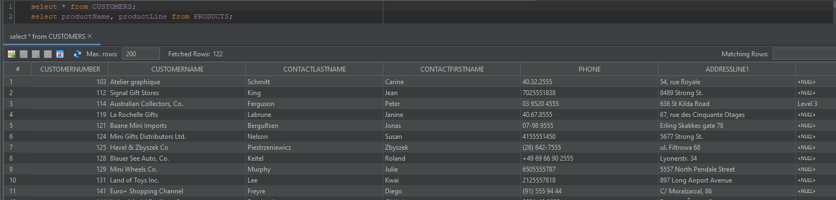

1. List the productName and the ProductLine that the product belongs to for all products.
   1. select productName, productLine from PRODUCTS;

|  |  |
| --- | --- |
| PRODUCTNAME | PRODUCTLINE |
| 1969 Harley Davidson Ultimate Chopper | Motorcycles |
| 1952 Alpine Renault 1300 | Classic Cars |
| 1996 Moto Guzzi 1100i | Motorcycles |
| 2003 Harley-Davidson Eagle Drag Bike | Motorcycles |
| 1972 Alfa Romeo GTA | Classic Cars |
| 1962 LanciaA Delta 16V | Classic Cars |
| 1968 Ford Mustang | Classic Cars |
| 2001 Ferrari Enzo | Classic Cars |
| 1958 Setra Bus | Trucks and Buses |
| 2002 Suzuki XREO | Motorcycles |
| 1969 Corvair Monza | Classic Cars |
| 1968 Dodge Charger | Classic Cars |
| 1969 Ford Falcon | Classic Cars |
| 1970 Plymouth Hemi Cuda | Classic Cars |
| 1957 Chevy Pickup | Trucks and Buses |
| 1969 Dodge Charger | Classic Cars |
| 1940 Ford Pickup Truck | Trucks and Buses |
| 1993 Mazda RX-7 | Classic Cars |
| 1937 Lincoln Berline | Vintage Cars |
| 1936 Mercedes-Benz 500K Special Roadster | Vintage Cars |
| 1965 Aston Martin DB5 | Classic Cars |
| 1980s Black Hawk Helicopter | Planes |
| 1917 Grand Touring Sedan | Vintage Cars |
| 1948 Porsche 356-A Roadster | Classic Cars |
| 1995 Honda Civic | Classic Cars |
| 1998 Chrysler Plymouth Prowler | Classic Cars |
| 1911 Ford Town Car | Vintage Cars |
| 1964 Mercedes Tour Bus | Trucks and Buses |
| 1932 Model A Ford J-Coupe | Vintage Cars |
| 1926 Ford Fire Engine | Trucks and Buses |
| P-51-D Mustang | Planes |
| 1936 Harley Davidson El Knucklehead | Motorcycles |
| 1928 Mercedes-Benz SSK | Vintage Cars |
| 1999 Indy 500 Monte Carlo SS | Classic Cars |
| 1913 Ford Model T Speedster | Vintage Cars |
| 1934 Ford V8 Coupe | Vintage Cars |
| 1999 Yamaha Speed Boat | Ships |
| 18th Century Vintage Horse Carriage | Vintage Cars |
| 1903 Ford Model A | Vintage Cars |
| 1992 Ferrari 360 Spider red | Classic Cars |
| 1985 Toyota Supra | Classic Cars |
| Collectable Wooden Train | Trains |
| 1969 Dodge Super Bee | Classic Cars |
| 1917 Maxwell Touring Car | Vintage Cars |
| 1976 Ford Gran Torino | Classic Cars |
| 1948 Porsche Type 356 Roadster | Classic Cars |
| 1957 Vespa GS150 | Motorcycles |
| 1941 Chevrolet Special Deluxe Cabriolet | Vintage Cars |
| 1970 Triumph Spitfire | Classic Cars |
| 1932 Alfa Romeo 8C2300 Spider Sport | Vintage Cars |
| 1904 Buick Runabout | Vintage Cars |
| 1940s Ford truck | Trucks and Buses |
| 1939 Cadillac Limousine | Vintage Cars |
| 1957 Corvette Convertible | Classic Cars |
| 1957 Ford Thunderbird | Classic Cars |
| 1970 Chevy Chevelle SS 454 | Classic Cars |
| 1970 Dodge Coronet | Classic Cars |
| 1997 BMW R 1100 S | Motorcycles |
| 1966 Shelby Cobra 427 S/C | Classic Cars |
| 1928 British Royal Navy Airplane | Planes |
| 1939 Chevrolet Deluxe Coupe | Vintage Cars |
| 1960 BSA Gold Star DBD34 | Motorcycles |
| 18th century schooner | Ships |
| 1938 Cadillac V-16 Presidential Limousine | Vintage Cars |
| 1962 Volkswagen Microbus | Trucks and Buses |
| 1982 Ducati 900 Monster | Motorcycles |
| 1949 Jaguar XK 120 | Classic Cars |
| 1958 Chevy Corvette Limited Edition | Classic Cars |
| 1900s Vintage Bi-Plane | Planes |
| 1952 Citroen-15CV | Classic Cars |
| 1982 Lamborghini Diablo | Classic Cars |
| 1912 Ford Model T Delivery Wagon | Vintage Cars |
| 1969 Chevrolet Camaro Z28 | Classic Cars |
| 1971 Alpine Renault 1600s | Classic Cars |
| 1937 Horch 930V Limousine | Vintage Cars |
| 2002 Chevy Corvette | Classic Cars |
| 1940 Ford Delivery Sedan | Vintage Cars |
| 1956 Porsche 356A Coupe | Classic Cars |
| Corsair F4U ( Bird Cage) | Planes |
| 1936 Mercedes Benz 500k Roadster | Vintage Cars |
| 1992 Porsche Cayenne Turbo Silver | Classic Cars |
| 1936 Chrysler Airflow | Vintage Cars |
| 1900s Vintage Tri-Plane | Planes |
| 1961 Chevrolet Impala | Classic Cars |
| 1980â€™s GM Manhattan Express | Trucks and Buses |
| 1997 BMW F650 ST | Motorcycles |
| 1982 Ducati 996 R | Motorcycles |
| 1954 Greyhound Scenicruiser | Trucks and Buses |
| 1950's Chicago Surface Lines Streetcar | Trains |
| 1996 Peterbilt 379 Stake Bed with Outrigger | Trucks and Buses |
| 1928 Ford Phaeton Deluxe | Vintage Cars |
| 1974 Ducati 350 Mk3 Desmo | Motorcycles |
| 1930 Buick Marquette Phaeton | Vintage Cars |
| Diamond T620 Semi-Skirted Tanker | Trucks and Buses |
| 1962 City of Detroit Streetcar | Trains |
| 2002 Yamaha YZR M1 | Motorcycles |
| The Schooner Bluenose | Ships |
| American Airlines: B767-300 | Planes |
| The Mayflower | Ships |
| HMS Bounty | Ships |
| America West Airlines B757-200 | Planes |
| The USS Constitution Ship | Ships |
| 1982 Camaro Z28 | Classic Cars |
| ATA: B757-300 | Planes |
| F/A 18 Hornet 1/72 | Planes |
| The Titanic | Ships |
| The Queen Mary | Ships |
| American Airlines: MD-11S | Planes |
| Boeing X-32A JSF | Planes |
| Pont Yacht | Ships |

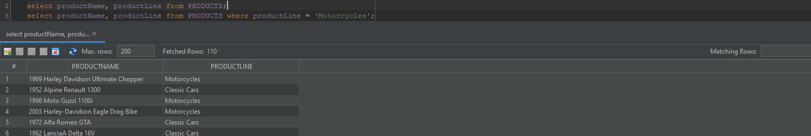

1. List all ProductNames where the ProductLine is ‘Motorcycles’
   1. select productName, productLine from PRODUCTS where productLine = 'Motorcycles';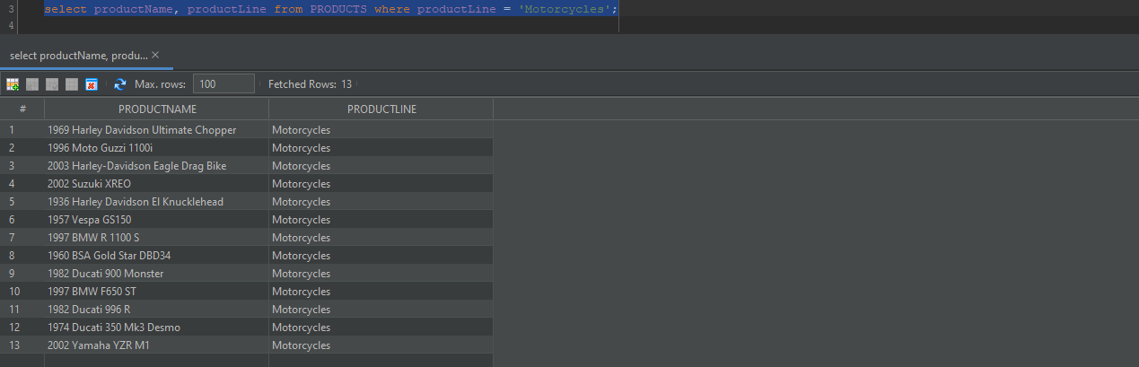
2. List the Vendor for the product whose productName is ‘1968 Ford Mustang’.
   1. select productVendor from PRODUCTS where productName = '1968 Ford Mustang';



1. List the Order Number, Order Status where the Order Status is ‘Resolved’ or ‘Cancelled’
   1. select orderNumber, status from ORDERS where status = 'Resolved' or status = 'Cancelled'; 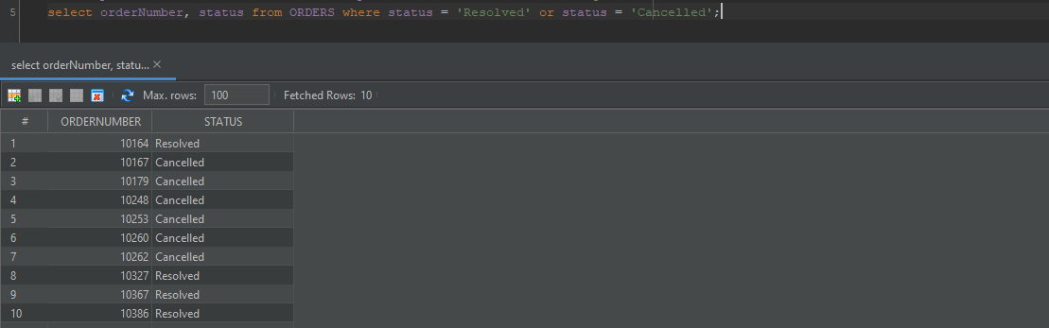
2. List the Order Number and Shipped Date for Orders that the Order Status is ‘Shipped’ and the Shipped Date is greater than Required Date.
   1. select orderNumber, shippedDate from ORDERS where status = 'Shipped' and shippedDate > requiredDate;

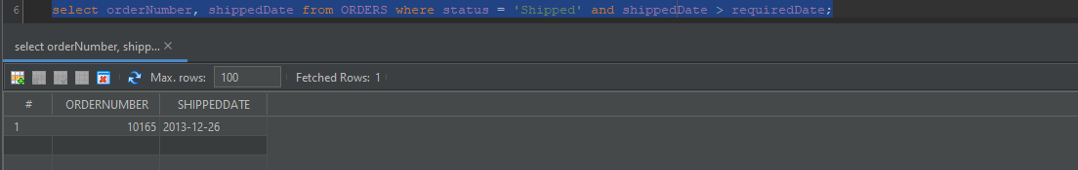

1. List the ProductName and Quantity in Stock where the BuyPrice is greater than the MSRP.
   1. select productName, quantityInStock from PRODUCTS where buyPrice > MSRP;

